Lab Assignment 1: Spinning Up React Native App

Muhabat Rahiq

CPRG 303

Jaspreet Gill

January 21, 2024

Lab Assignment 1: Spinning Up React Native App

1. **System requirements:**

Before you start with React Native development, ensure that your system meets the requirement. For example, check your CPU, RAM, and windows version.

CPU: intel Core i5

RAM: 8.00 GB

Windows version: Windows 10 Pro 22H2

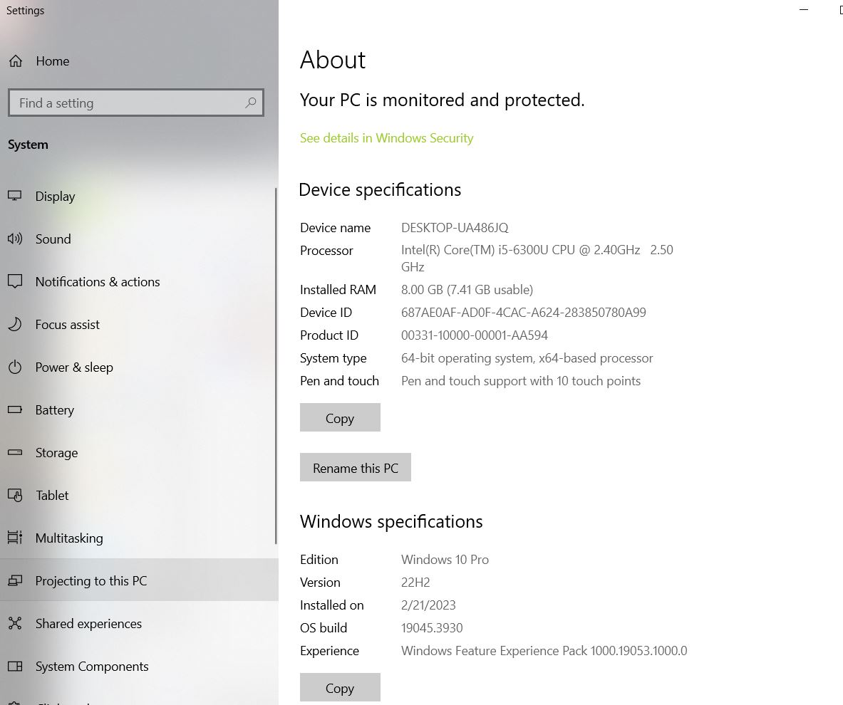

1. **Installation Instruction:**

* Node.js: Download and install the latest version of Node.js.
* Open window terminal and run check version by the following command:

*>node -v*

*>npm –v*

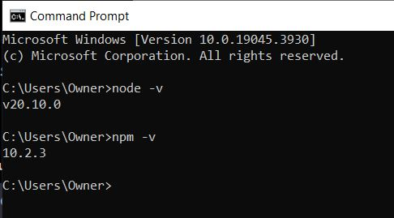

* Expo CLI: Install Expo CLI globally by running the following command:

*>npm install expo-cli –global* OR *>npm install - -global expo-cli*

* Expo Go: install Expo Go on your mobile device from the App Store or Google Play

1. **Configuration Steps:**

* Environment Variables: Set necessary environment variables, such as API keys, in a .env file or save the project in C drive (local disk)
* Project Settings: Adjust project settings in the app.json file if needed.

1. **Project Creation:**

* Change directory to C drive by using the command *>cd C:\CPRG303\Demo*
* Create the project by using the command *>npx create-expo-app IncredibleTodoListApp*
* To get inside the project directory, use the cd command *>cd IncredibleTodoListApp*
* To navigate to VSCode use the command  *>Code .*

1. **Running the Project:**

* To run the project, run ‘npm start’ in the project directory *>npm start*
* Scan the QR code and the project will open in EXpo Go on your device

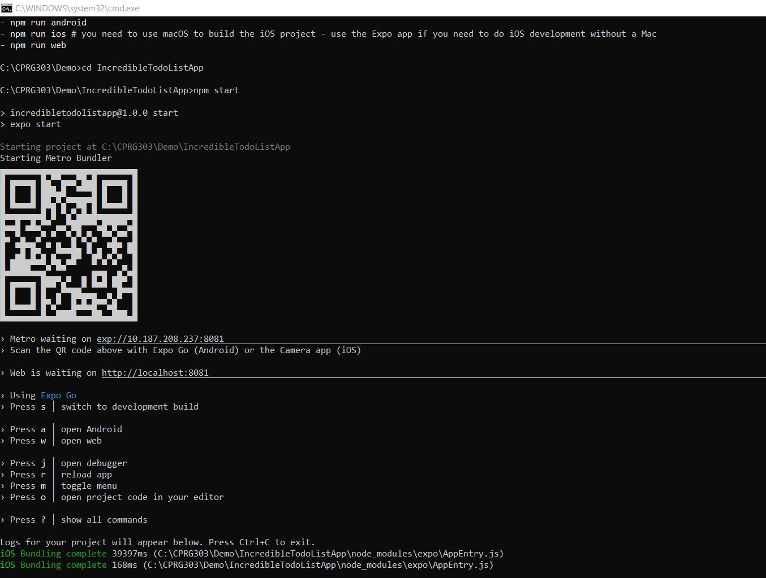

1. **Troubleshooting:**

* At first I named the project as Incredible Todo List App and it gave me an error message of “unknown argument” because it had space. So, when I tried the project name again with no space then it created the project for me.

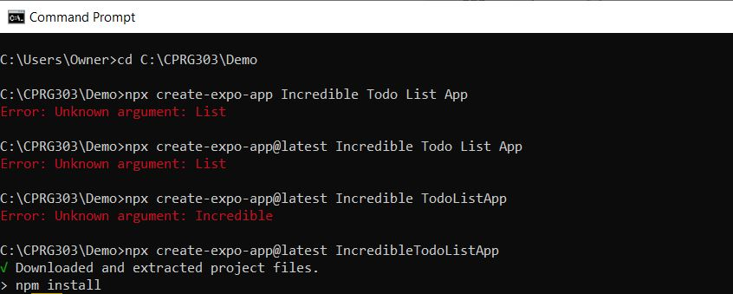

1. **Resources:**

React Native. (2023, Dec 08). Setting up the development environment. 2024, Jan 19. Retrieve from: (<https://reactnative.dev/docs/environment-setup?guide=native).>